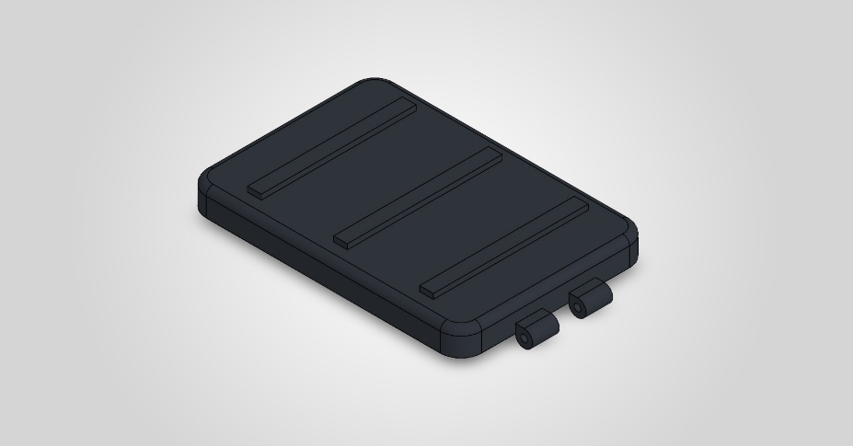
  Simulation of Upper Valve-Chasis
  Date: 04 October 2026
  Designer: Solidworks
  Study name: SimulationXpress Study
  Analysis type: Static
  Table of Contents
  Description 1
  Assumptions 2
  Model Information 2
  Material Properties 3
  Loads and Fixtures 3
  Mesh information 4
  Study Results 6
  Conclusion 8

Description
No Data

Assumptions

Model Information

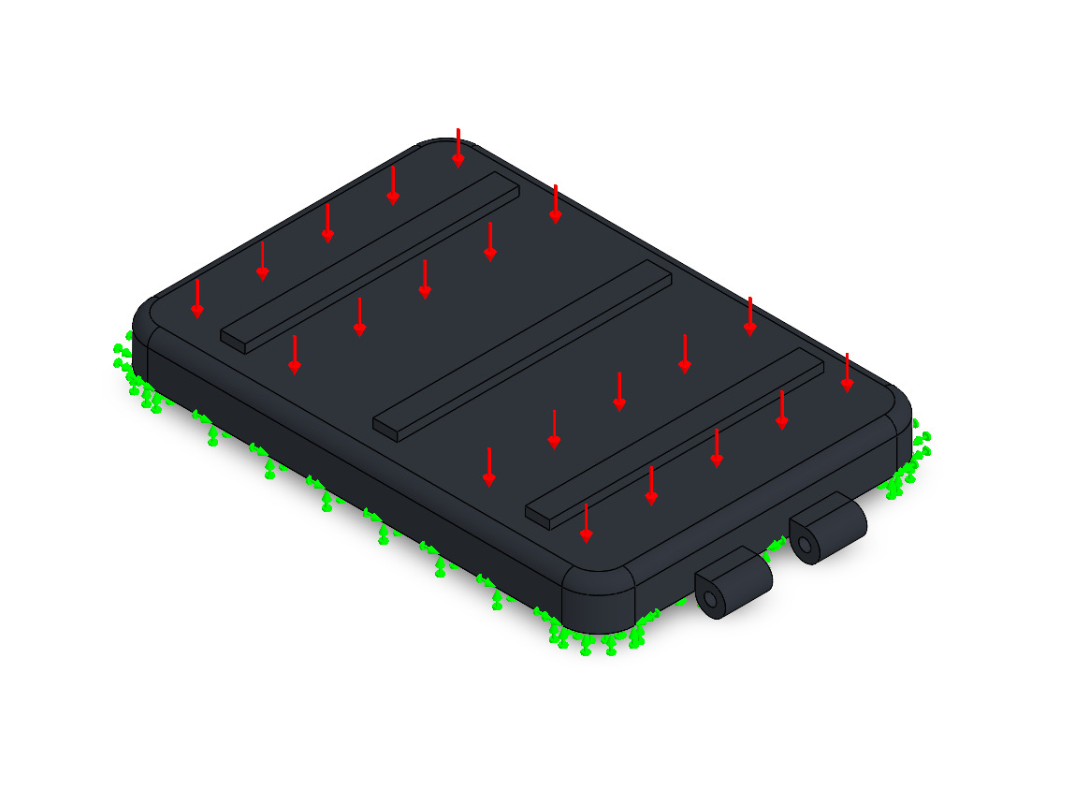
Model name: Upper Valve-Chasis
Current Configuration: Default
Solid Bodies
Document Name and Reference | Treated As | Volumetric Properties | Document Path/Date Modified
LPattern1  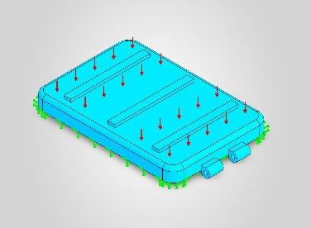 | Solid Body | Mass:0.162512 kg  Volume:0.000119494 m^3  Density:1,360 kg/m^3  Weight:1.59261 N | C:\Users\E.Kay\ANTARES PROJECT\HEXAPOD\Upper Valve-Chasis.SLDPRT  Oct 4 15:22:28 2026

Material Properties
Model Reference | Properties | Components
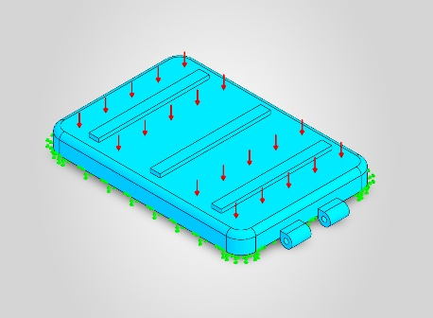 |  | SolidBody 1(LPattern1)(Upper Valve-Chasis)
  Name: | PA6-GF30
  Model type: | Linear Elastic Isotropic
  Default failure criterion: | Unknown
  Yield strength: | 1.3e+08 N/m^2
  Tensile strength: | 1.3e+08 N/m^2

Loads and Fixtures
Fixture name | Fixture Image | Fixture Details
Fixed-1 | 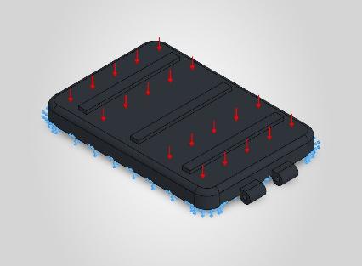
  Entities: | 1 face(s)
  Type: | Fixed Geometry

Load name | Load Image | Load Details
Pressure-1 (:10,000 N/m^2:) | 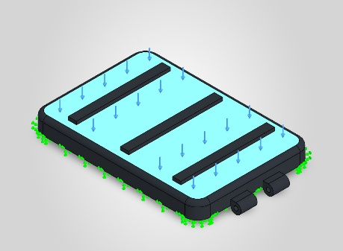
  Entities: | 1 face(s)
  Type: | Normal to selected face
  Value: | 10,000
  Units: | N/m^2

Mesh information
Mesh type | Solid Mesh
Mesher Used: | Standard mesh
Automatic Transition: | Off
Include Mesh Auto Loops: | Off
Jacobian points for High quality mesh | 16 Points
Element Size | 4.92696 mm
Tolerance | 0.246348 mm
Mesh Quality | High

Mesh information - Details
Total Nodes | 15123
Total Elements | 8026
Maximum Aspect Ratio | 5.9018
% of elements with Aspect Ratio < 3 | 98.6
Percentage of elements with Aspect Ratio > 10 | 0
Percentage of distorted elements | 0
Time to complete mesh(hh;mm;ss): | 00:00:09
Computer name:
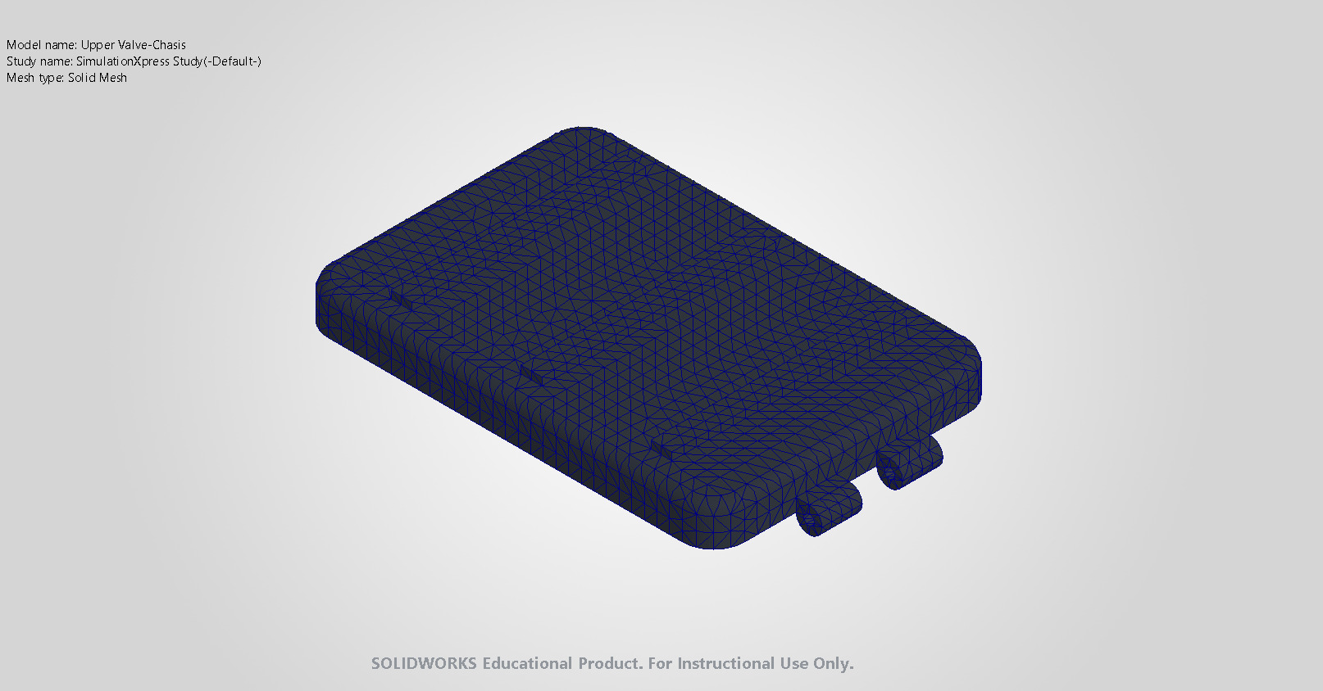

Study Results

Name | Type | Min | Max
Stress | VON: von Mises Stress | 8.573e+02N/m^2  Node: 14720 | 1.102e+06N/m^2  Node: 2913
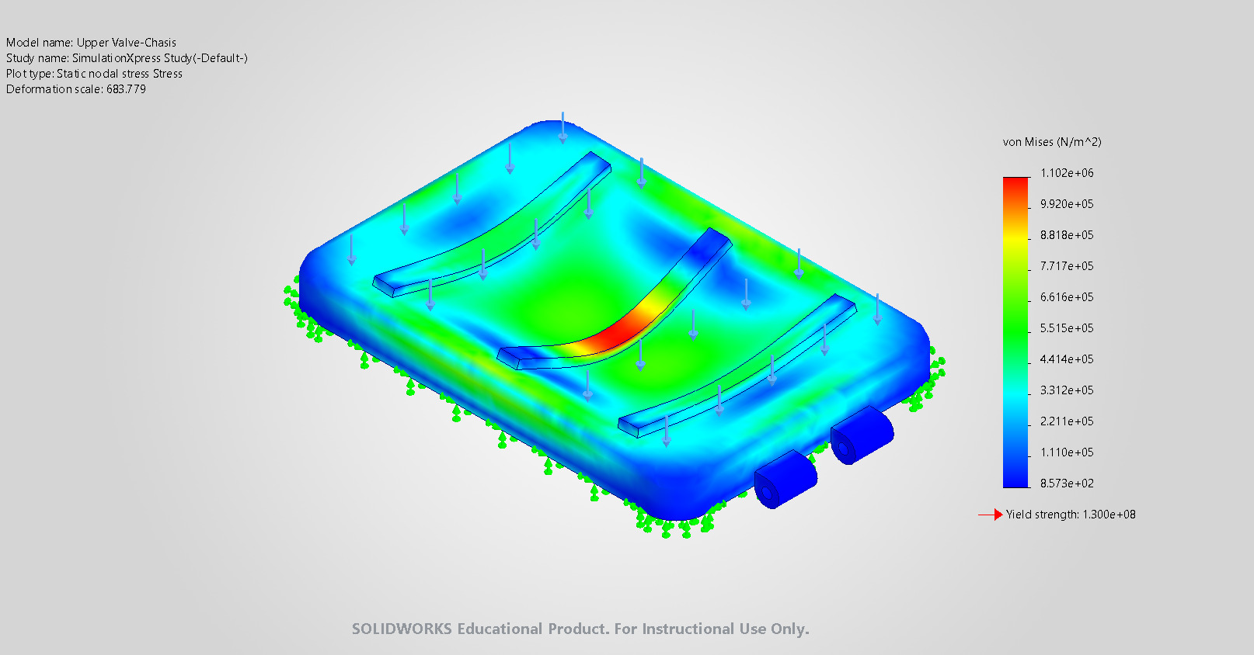
Upper Valve-Chasis-SimulationXpress Study-Stress-Stress

Name | Type | Min | Max
Displacement | URES: Resultant Displacement | 0.000e+00mm  Node: 74 | 2.486e-02mm  Node: 12087
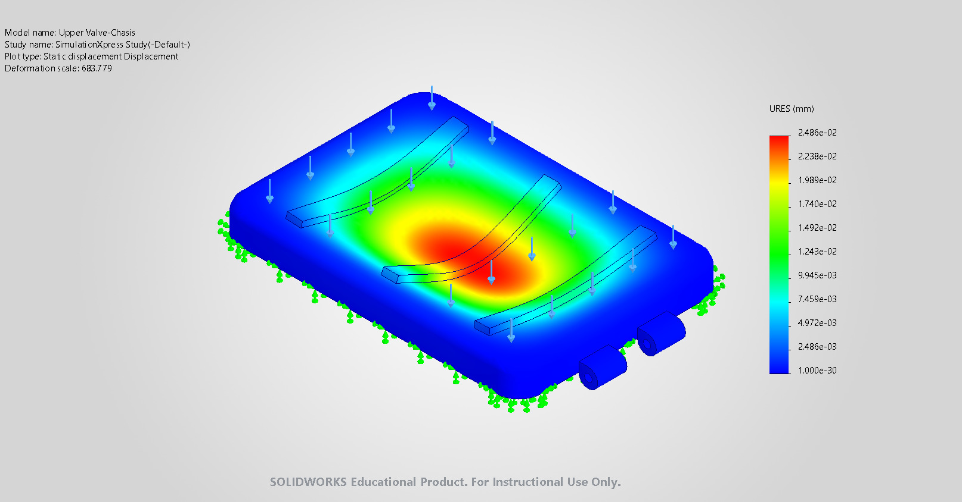
Upper Valve-Chasis-SimulationXpress Study-Displacement-Displacement

Name | Type
Deformation | Deformed shape
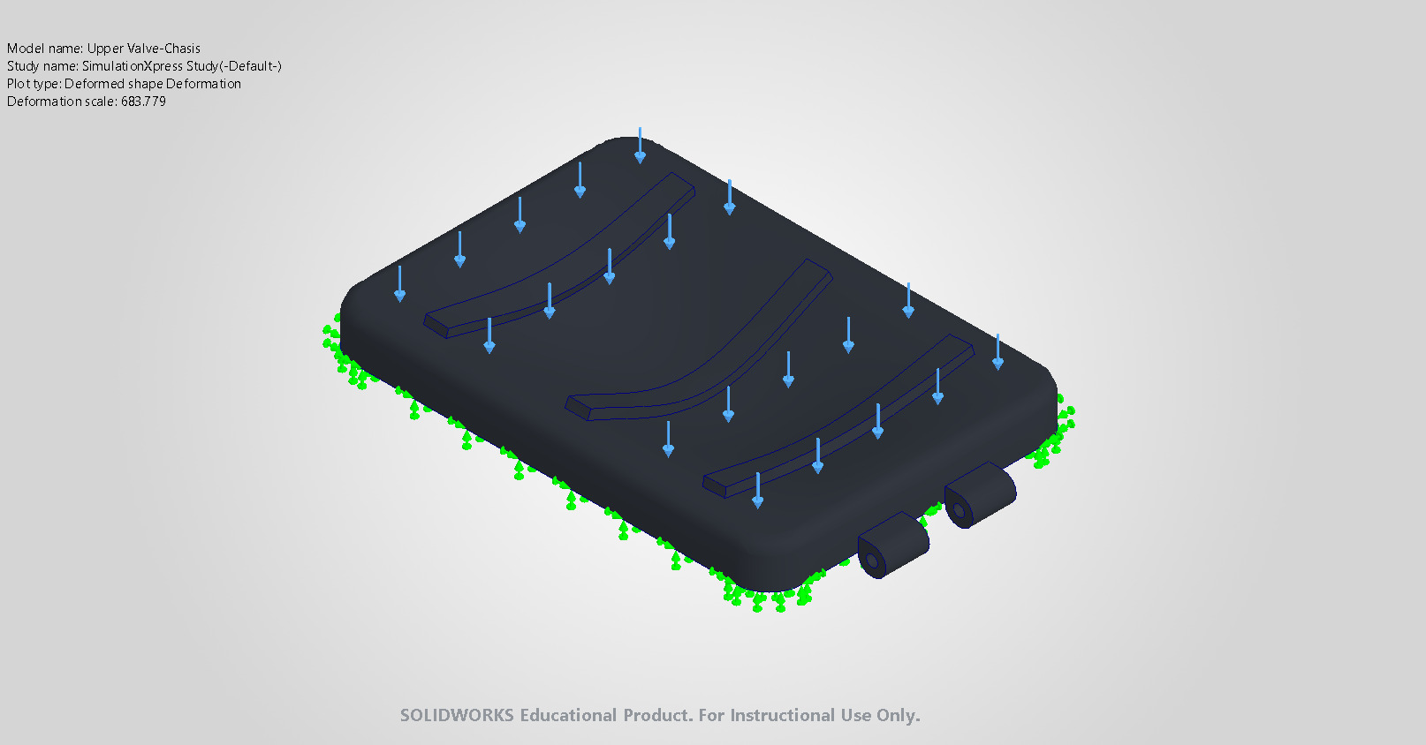
Upper Valve-Chasis-SimulationXpress Study-Displacement-Deformation

Name | Type | Min | Max
Factor of Safety | Max von Mises Stress | 1.180e+02  Node: 2913 | 1.516e+05  Node: 14720
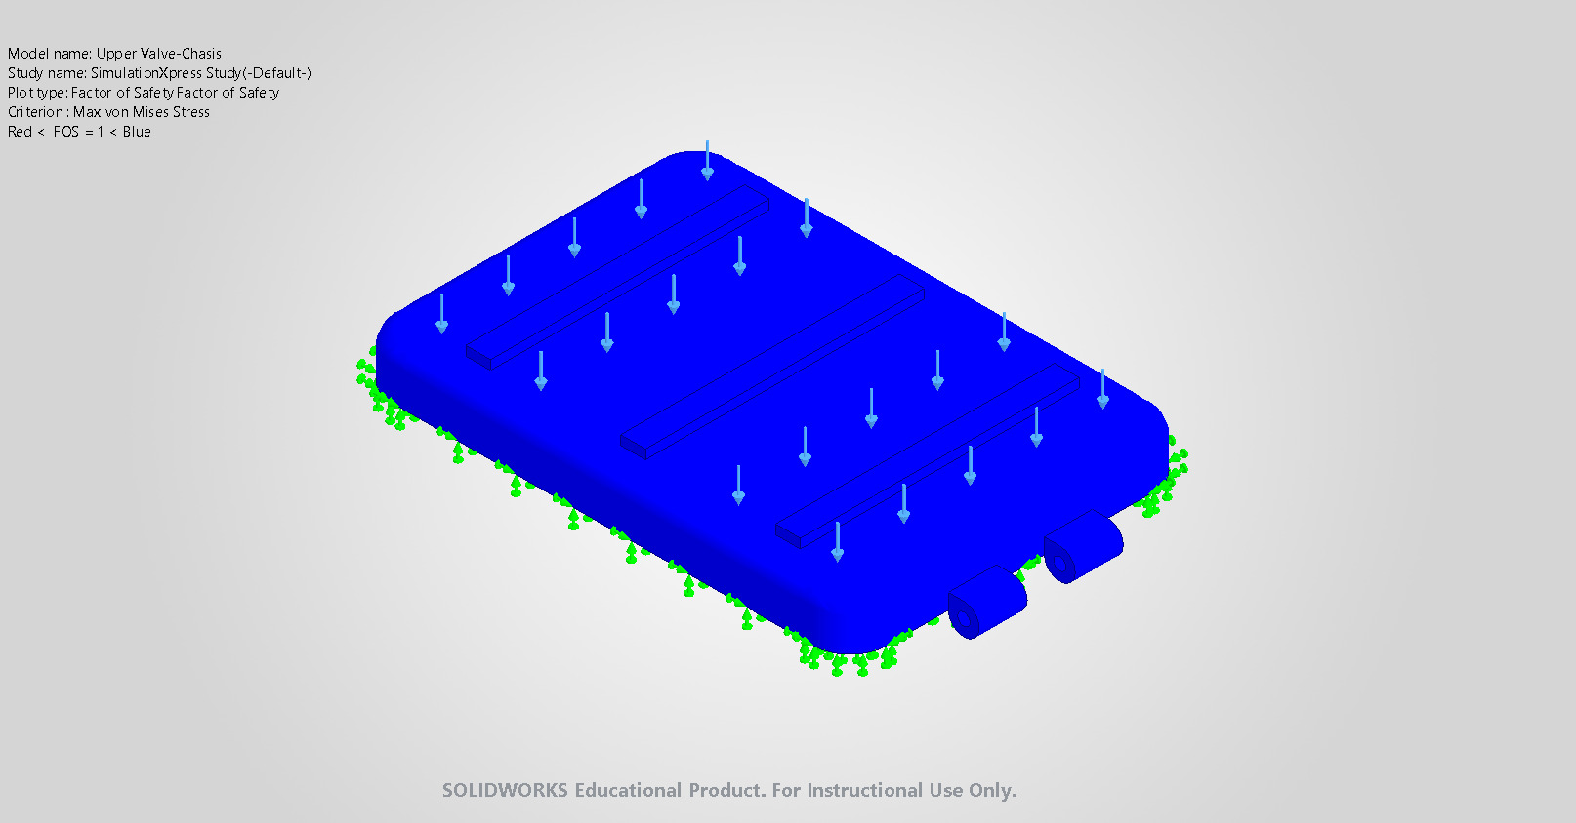
Upper Valve-Chasis-SimulationXpress Study-Factor of Safety-Factor of Safety

Conclusion

